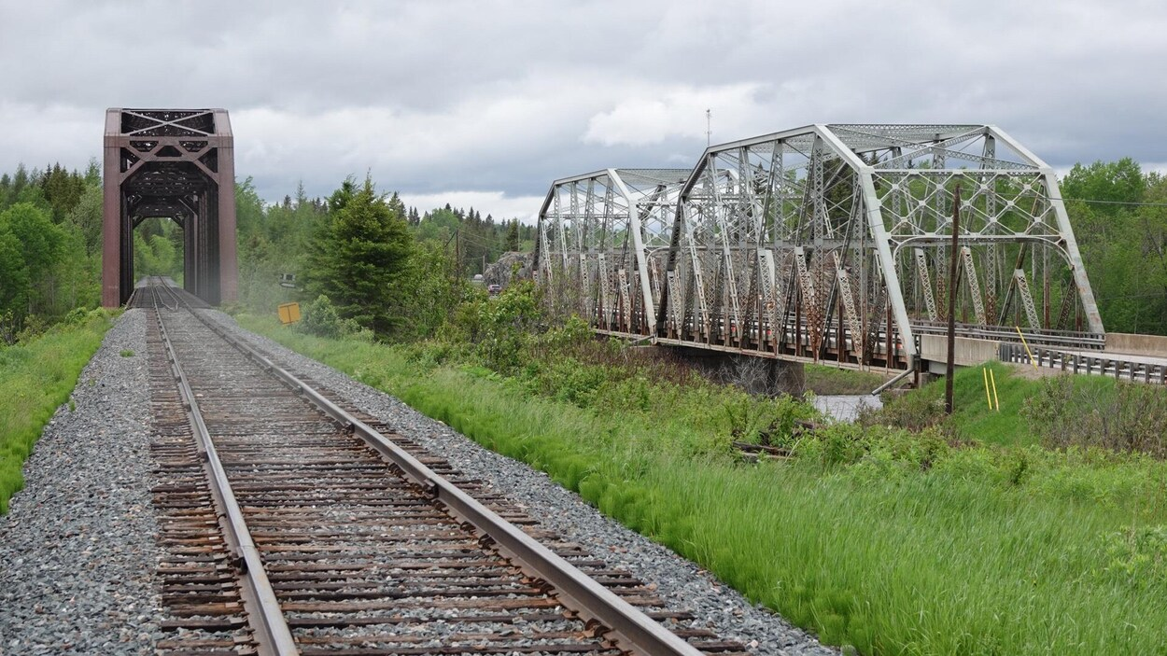  - August 5, 6 & 7, 2022  fauquier 100th anniversary celebrations  2022 marks the centennial celebration for the Township of Fauquier! Join us for the big celebration as we commemorate the culture, history and pioneers who founded our beautiful community.  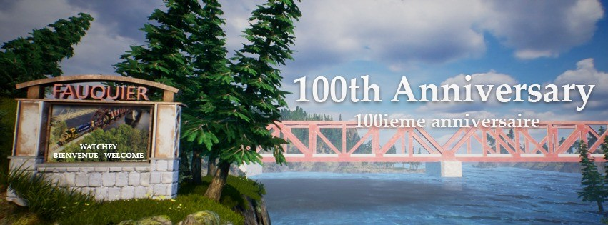 | Meet & Greet, BBQ’s, Spaghetti supper, games for all ages, historical memorabilia’s, live music and more…  ____  Don’t miss this opportunity to connect with old friends & family!  ____  A memorable event you don’t want to miss!  ____  Let’s celebrate Fauquier together!  ____  1922 - 2022  Visit our web page at www.fauquierstrickland.com for up-to-date event information  Camping spots available for your convenience!  Call the Municipal Office at (705) 339-2521 for more information

